**Risk of T1D Complications Neuropathy, Retinopathy, and Nephropathy Predicted from Clinical Variables**

**Clinical Risk of Type 1 Diabetes Complications: A tool to motivate change in patient behavior**

Paul Minh Huy Tran 1□, Sharad Purohit 1,2,3□, Lynn Kim Hoang Tran 1, bin Satter Khaled1, Wenbo Zhi 1,2, Shan Bai1, Diane Hopkins 1, Leigh Steed1, Bruce Bode4, Stephen W. Anderson5, John Chip Reed6, R. Dennis Steed6 and Jin-Xiong She 1,2,*

1 Center for Biotechnology and Genomic Medicine; Medical College of Georgia, Augusta University, 1120, 15th St, Augusta GA 30912, USA; [spurohit@augusta.edu](mailto:spurohit@augusta.edu) (S.P.); [wzhi@augusta.edu](mailto:wzhi@augusta.edu) (W.Z.); [lytran@augusta.edu](mailto:lytran@augusta.edu) (L.K.H.T.); [ptran@augusta.edu](mailto:ptran@augusta.edu) (P.M.H.T.); bdun@augusta.edu (B.D.); [dhopkins@augusta.edu](mailto:dhopkins@augusta.edu) (D.H.)

2 Department of Obstetrics and Gynecology, Medical College of Georgia, Augusta University, 1120, 15th St, Augusta GA 30912, USA

3 Department of Undergraduate Health Professionals, College of Allied Health Sciences, Augusta University, 1120, 15th St, Augusta GA 30912, USA

4 Atlanta Diabetes Associates, Atlanta, GA, USA;

5 Pediatric Endocrine Associates, Atlanta, GA, USA;

6Southeastern Endocrine and Diabetes, Atlanta, GA, USA;

**\*** Correspondence: [jshe@augusta.edu](mailto:jshe@augusta.edu)

**Keywords:** Type 1 Diabetes, Peripheral Neuropathy, Autonomic Neuropathy, Retinopathy, Nephropathy, Risk Prediction

**Financial support:** This work was supported by grants from the National Institutes of Health (R21HD050196, R33HD050196, and 2RO1HD37800) and JDRF (1-2004-661) to JXS. SP (2-2011-153, 10-2006-792 and 3-2004-195) and WZ (3-2009-275) were supported by Postdoctoral Fellowship and Career Development Award from JDRF. PMHT was supported by NIH fellowship (F30DK12146101A1). This work was partially supported by the Georgia Research Alliance Eminent Scholar Program to JXS.

**Correspondence**: Jin-Xiong She, PhD

Address: Center for Biotechnology and Genomic Medicine, Medical College of Georgia at Augusta University, 1120 15th St, Augusta, GA, 30912

Telephone: (706)-721-3410

Fax: (706)-721-3688

Email: [jshe@augusta.edu](mailto:jshe@augusta.edu)

**Conflict of Interest:** The authors declare no potential conflicts of interest.

Word count: (limit 4000) Figures and tables: (limit 4)

**ABSTRACT** (Word Count: 237, limit 250)

**Objective:** (the purpose or hypothesis of study)

**Research Design and Methods:** (the basic design, setting, number of participants and selection criteria, treatment or intervention, and methods of assessment)

**Results:** (significant data found)

**Conclusions:** (the validity, limitations, and clinical applicability of the study and its results)

**INTRODUCTION**

Both type 1 and type 2 diabetes are associated with disease specific complications of diabetic peripheral neuropathy (DPN), cardiac autonomic neuropathy (CAN), diabetic retinopathy (DR), and diabetic nephropathy (DN). With the increasing incidence and survival of patients with type 1 diabetes, these complications are becoming more important to study for type 1 diabetes. These complications are associated with their own morbidity and mortality. Peripheral neuropathy can lead to diabetic foot ulcers and potentially amputations. Retinopathy can lead to blindness. Diabetic nephropathy can lead to end stage renal disease and need for dialysis.

Secondary prevention of these complications through lifestyle changes remains the most effective approach to prevent sequelae from these diabetic complications. Through patient diabetes education, patients understand their diagnosis increases their risk of these complications. However, patient non-compliance with lifestyle and medication recommendations is a primary driver for diabetic complications. Reported modifiable clinical risk factors include [hypercholesterolemia] (https://jamanetwork.com/journals/jamanetworkopen/fullarticle/2734805#:~:text=Findings%20In%20this%20cross%2Dsectional,is%20associated%20with%20diabetic%20polyneuropathy), [hypertension] (https://www.ncbi.nlm.nih.gov/pmc/articles/PMC6636691/). predictors of [nephropathy, retinopathy, and neuropathy] (https://jmai.amegroups.com/article/view/5197/html). DCCT 90s trial on hba1c control and complication rates. One potential reason is that patients are not aware of their individual risk for diabetic complications. Learning this risk may motivate patients to progress on the Prochaska and DiClemente cycle of change.

Risk scores have been reported in the past for diabetic complications. [Kazemi et al] (https://pubmed.ncbi.nlm.nih.gov/27032459/) published a support vector machine model using 13 clinical variables to predict DPN severity with accuracy of 76%. [Lagani et al] (https://pubmed.ncbi.nlm.nih.gov/25772254/) used the DCCT data to predict time to DPN and DAN development using five variables, HbA1C, albumin, age, retinopathy level, and post-pubescent diabetes duration with AUC of 0.74 on test dataset. DCCT/EDIC models ([website](https://www.niddk.nih.gov/about-niddk/research-areas/diabetes/blood-glucose-control-studies-type-1-diabetes-dcct-edic)) (<https://diabetes.diabetesjournals.org/content/69/5/1000>)

Dpn risk calculated with the variables mean HbA1c, age, height, t1d dur, DR, AER, mean pulse, and bb use. Can risk calculated with the variables age, aer, hba1c, t1d dur, pulse, bb use, sbp, DR, macular edema, eGFR <60, and smoker.

However, there are several problems. First, these scores are not easily accessible for patients and clinicians to calculate there risk of diabetic complications. Second, the scores for each complication use different clinical variables, making it more difficult for patients to collect all of the data necessary for computing clinical risk for each complication. Third, these scores do not show patients how changing their modifiable risk factors would change their risk of developing diabetic complications. Scores should be easily accessible and easy to use because they are important for progress monitory, which has been shown to be important to reduce unrealistic optimism (<https://www.ncbi.nlm.nih.gov/pmc/articles/PMC3204264/> )

The T1D population is unique in that the patient population is younger and taking preventative measures against diabetic complications may be more difficult to incentivize in this population. We used an independent cross sectional study, PAGODA, to develop a clinical risk score for DPN, CAN, DR, and DN in T1D patients.

**METHODS**

*Study population*

Selection criteria

Subjects were recruited into the Phenome and Genome of Diabetes Autoimmunity (PAGODA) study between 2002 and 2010. These subjects attended the Augusta University (AU) Medical Center and/or endocrinology clinics in Augusta and Atlanta area of Georgia [1]. Presence of DPN and CAN was confirmed by consulting the neurologist. Presence of DR was confirmed by a board-certified ophthalmologist. Presence of DN was confirmed through eGFR calculated from clinical data and was independently validated using an in-house urine creatine and microalbumin assay. Medical history, clinical and demographic profiles for T1D subjects were captured from the medical charts available at the endocrinology clinic (Table 1). The research was carried out according to The Code of Ethics of the World Medical Association (Declaration of Helsinki, 1997). All study participants gave written informed consent. The study was reviewed and approved by the institutional review board at AU.

*Statistical Analysis*

The potential differences between T1D patients with and without each complication (DPN, CAN, DR, and DN) were initially examined using univariate logistic regression. Multivariate logistic regression models were constructed to develop a clinical risk score for each diabetic complication. We compared three feature selection methods. The first is least absolute shrinkage and selection operator (LASSO) algorithm as implemented in the “glmnet” package with the “binomial” family to use the logit link function. This algorithm applies a regularization factor to each variable which can shrink the coefficient to “0” effectively removing the variable from the score calculation. The second is recursive feature elimination (RFE), which starts with a full additive logistic regression model of all potential clinical variables and randomly removes a prespecified number of variables randomly. It does this process iteratively down to the lowest number of variables specified by the user (one in our case). The algorithm then compares all of the models and selects the model with the smallest root mean squared error and then the smallest number of variables. We applied the RFE algorithm as implemented in the “caret” package with model sizes attempted 1,5,7,8,10,13, 15, 18, and 21. The third model was constructed from variables we manually selected for as showing consistent association with diabetic complications across multiple studies and for clinical variables which are modifiable through lifestyle changes and medication management. We selected four variables: age on date of consent, duration of type 1 diabetes on date of consent, average HbA1C value from the last three clinic visits, and average systolic blood pressure from the last three clinic visits.

The area under the curve values of the receiver-operator characteristics (AUROC) curve analysis was applied to evaluate the performance of each model.

All P-values were two-tailed and a p< 0.05 was considered statistically signiﬁcant. All statistical analyses were performed using the R language and environment for statistical computing (R version 3.6.1; R Foundation for Statistical Computing; [www.r-project.org](http://www.r-project.org)).

**RESULTS**

*Diabetic Complications*

We consented a cross sectional cohort of 1646 patients diagnosed with type 1 diabetes. Of the 1646 patients, 199 were diagnosed with diabetic peripheral neuropathy (DPN), 63 were diagnosed with cardiac autonomic neuropathy (CAN), 244 were diagnosed with diabetic retinopathy (DR), and 88 were diagnosed with diabetic nephropathy (DN). Of the patients with DPN, 172 had focalized DPN and 30 had generalized DPN. Additionally, 25 had diabetic foot ulcers and 17 had limb amputations. Of the patients with DR, 167 have had photocoagulation and 42 are blind. The diagnosis of any of the diabetic complications is associated with the other three (Figure 1). All other clinical variable distributions are shown in Table 1.

*Individual risk factors associated with diabetic complications*

Female patients are more likely to have DPN and DR. Smoking status is not associated with any diabetic complications. Past medical history of hypertension, dyslipidemia, coronary artery disease or previous myocardial infarction or cerebrovascular accident are associated with all four complications. Previous transient ischemic attack is associated with all except CAN. A patient’s age at day of consent, duration of type 1 diabetes diagnosis, and age of type 1 diabetes diagnosis are associated with all four complications.

For laboratory values, hemoglobin and average BUN from the last three clinic visits are associated with all four complications. HDL level is associated with all complications except DN. Microalbuminuria and albumin-creatinine ratio are associated with all complications except CAN. Albumin levels are associated with DR and DN. Total cholesterol levels are associated with DR. The average serum creatinine level from the last 3 clinic visits was associated with DN. The average HbA1C level from the last 3 clinic visits, the maximum HbA1C level from the last 3 clinic visits, the HbA1C level from the last clinic visit were not associated with any complications. LDL and triglyceride levels were not associated with any complications.

For medications, use of acetaminophen, atorvastatin, and ibandronate are associated with all complications. Intake of insulin aspart, insulin glargine, lisinopril, ramipril, and lovastatin were associated with all complications except CAN. Intake of ThYes and simvastatin is associated with all complications except DN. Levothyroxine intake is associated with DPN and DR. Escitalopram intake is associated with DPN and CAN. Human recombinant insulin use is associated with CAN and DR. Insulin isophane human use is associated with DPN. Insulin detemir use is associated with CAN. Valsartan and insulin lispro use are not associated with any complications.

Individual odds ratios for clinical variables associated with each diabetic complication are shown in Table 2.

*Multivariate predictive model of complications*

We selected 22 clinical variables to use in the supervised model based on the univariate analysis. These were sex, past medical history of DPN, CAN, DR, DN, HTN, dyslipidemia, CAD, prior TIA, MI, or CVA, age on date of consent, duration of type 1 diabetes, serum level of hemoglobin, HDL, and albumin during the last clinic visit, average level of serum creatinine, BUN, and HbA1C during the last 3 clinic visits, average urine microalbumin during the last 3 clinic visits, average systolic blood pressure during the last 3 clinic visits, and maximum HbA1C in the last 3 clinic visits. We compared three feature selection methods to determine the optimal logistic regression model with trade off between accuracy and simplicity. The methods were least absolute shrinkage and selection operator (LASSO), recursive feature elimination (RFE), and manual selection made a priori to data analysis.

For DPN, the LASSO method selected 12 variables with a test set Area Under the Receiver Operating Characteristics (AUROC) of 0.9125. The RFE method selected 5 variables with a test set AUROC of 0.8882. We selected four variables, age on date of consent, duration of type 1 diabetes, average systolic blood pressure from the last three clinic visits, and average HbA1C from the last three clinic visits, with a test set AUROC of 0.8941.

For CAN, the LASSO method selected 8 variables with a test set Area Under the Receiver Operating Characteristics (AUROC) of 0.8835. The RFE method selected 8 variables with a test set AUROC of 0.7683. We selected the same four variables with a test set AUROC of 0.812.

For DR, the LASSO method selected 14 variables with a test set Area Under the Receiver Operating Characteristics (AUROC) of 0.9097. The RFE method selected 1 variables with a test set AUROC of 0.8689. We selected the same four variables with a test set AUROC of 0.8951.

For DN, the LASSO method selected 15 variables with a test set Area Under the Receiver Operating Characteristics (AUROC) of 0.7144. The RFE method selected 5 variables with a test set AUROC of 0.8442. We selected the same four variables with a test set AUROC of 0.8571.

Our custom models are in general more simple and have similar test set AUROC to the other automated feature selection methods. The clinical variables selected by each model are shown in Table 3.

*Predict individual diabetic complication risk*

We created a web interface (ptran25.shinyapps.io/Diabetic_Peripheral_Neuropathy_Risk) (Figure 2) for individuals to enter their data to estimate their specific risk of diabetic complications. This interface was created to inform patients of their individual risk of complications and for them to be motivated to reduce their complication risk by reducing their blood pressure and HbA1C.

We generated nomograms to help individuals understand how their modifiable risk factors are associated with diabetic complications in relation to other clinical variables (Figure 3).

**DISCUSSION**

Comment on hba1c and complication risk

Comment of blood pressure/htn and complication risk

Comment on dyslipidemia/cholesterol/etc and complication risk

Comment on age/dur use and novelty/importance of interaction

Comment on importance of the clinical tool accessible to all

All diabetic complications are related and wanted to characterize risk for all based on clinical risk factors. This allows us to compare and contrast the risk factors compared to other studies.

Most of the univariate risk agrees with previous reports of risk factors for complications.

Hba1c was not significant of univariate, but significant on multivariate, meaning hba1c is important in the context of other associated factors.

This model is validated and strongly predictive of risk using only clinical factors.

Limitations of this study is its cross sectional nature, which does not allow for temporal understanding of the variables. For example, we are not able to discern if statin and acei use association with complications is directly related or through the underlying diagnosis leading to use of the medication.

**CONCLUSION**

**Acknowledgements**

We thank a number of physicians (Andy Muir, David Brown, N. Spencer Welch, Paul Davidson, Joseph Johnson, David Robertson, Constance Baldwin, Melissa Carlucci, Mark Rappaport, Robert Schultz, Vijayasudha Gunna) and staff members (Kim English, Jessica Leggett, Katherine Guthrie, Melanie Brown, Deana McFeely, Nellie Jenkins, JoAnn Higdon, Debbie Ellison, Tami Kinnersley and Ann Simmonds) for their contribution in sample collection. We are very grateful to all patients and other volunteers who participated in this study.

**References**

**Tables**

**Figures**



**Figure 1. Venn diagram of PAGODA patients with DPN, CAN, DR, and DN.**

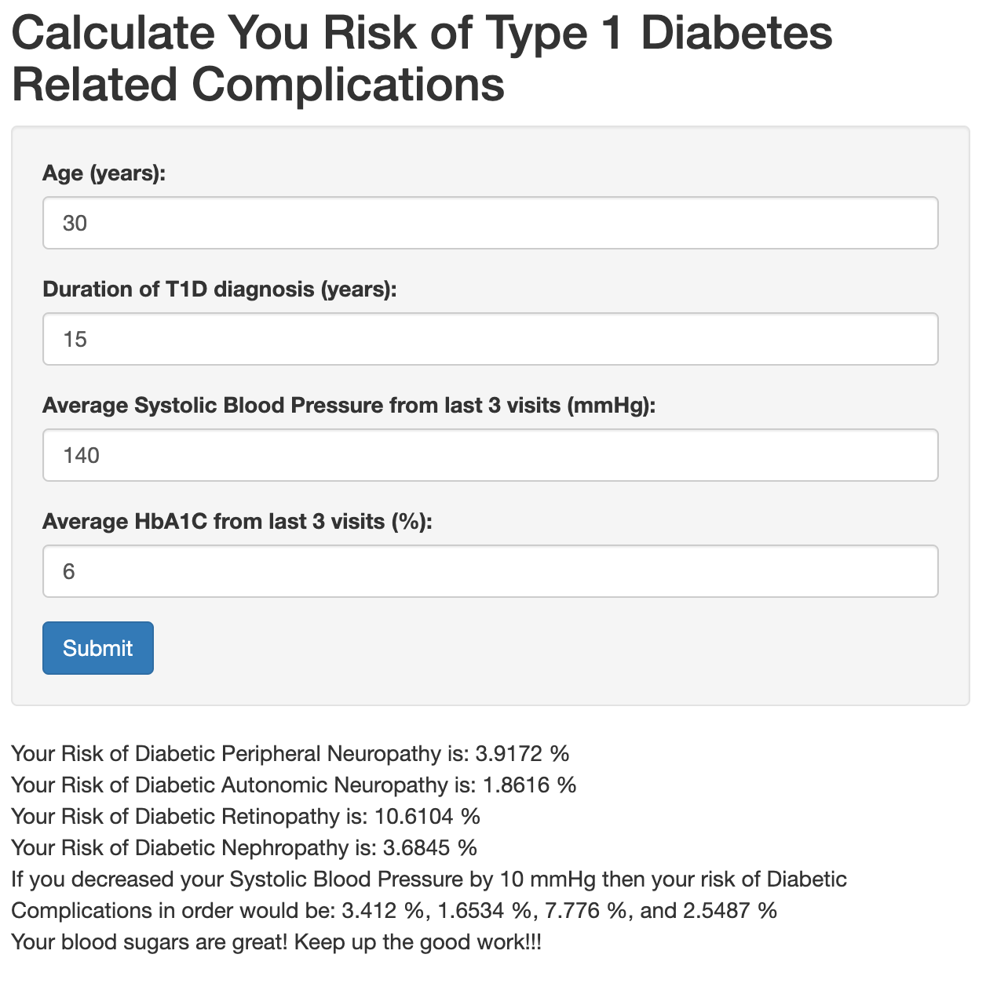

**Figure 2. Screenshot of web interface for informing and motivating type 1 diabetes patients to modify their risk of diabetic complications.**



**Figure 3. Nomogram of Clinical variables and their associated risk for DPN (A), CAN (B), DR (C), and DN (D) in a multivariate logistic regression model.**